**Employee Attrition Analysis Report**

**Overview**

This analysis identifies key factors driving employee attrition and offers actionable recommendations to improve retention. A Logistic Regression model was used to predict at-risk employees, achieving good accuracy.

**Key Findings**

* Attrition Distribution:

The bar chart above shows the number of employees who left vs. those who stayed.

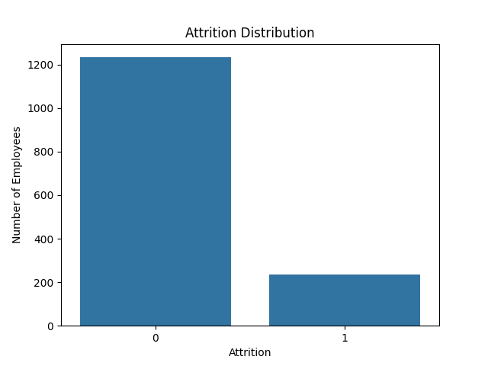

Figure 1: Attrition Distribution

* Correlation Between Variables:

The heatmap highlights the relationships between various features and attrition, emphasizing the importance of job satisfaction, work-life balance, and other factors.

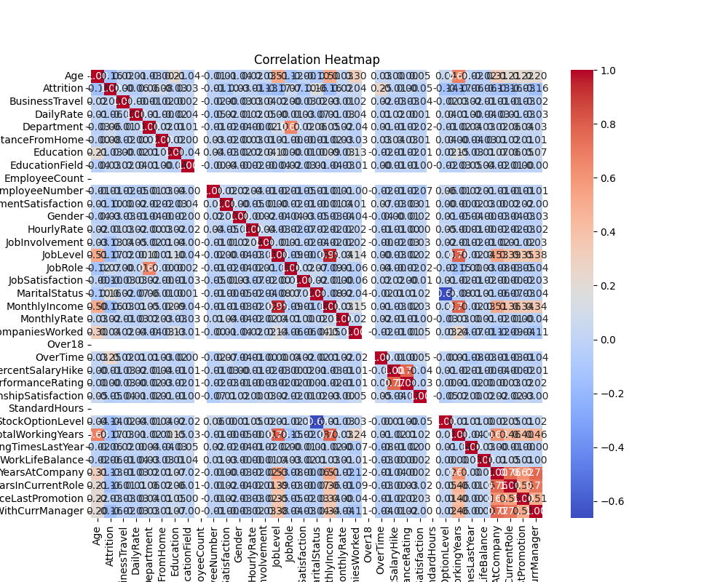

Figure 2: Correlation Heatmap

* Age vs. Attrition:

The boxplot indicates that younger employees, particularly those between 25–35 years old, are more likely to leave.

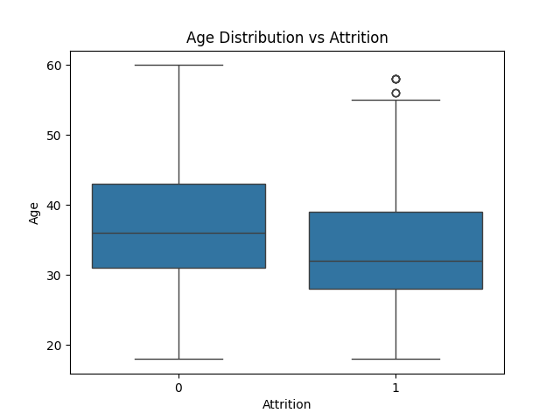

Figure 3: Age vs. Attrition

* Model Evaluation (Confusion Matrix):

The confusion matrix helps evaluate the model’s effectiveness, showing its performance in predicting attrition.

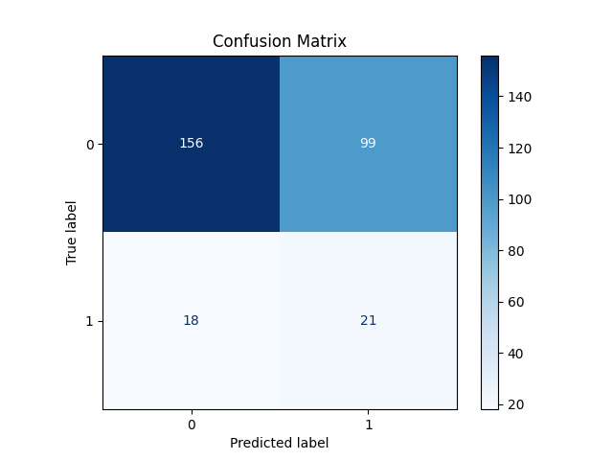

Figure 4: Confusion Matrix

**Recommendations**

1. **Retention Strategies:**
   * Enhance career development plans and mentorship for younger employees.
   * Offer competitive pay and flexible work options to improve satisfaction.
2. **Proactive Monitoring:**
   * Use predictive modeling regularly to identify and support at-risk employees.
3. **Engagement Programs:**
   * Conduct feedback surveys and address employee concerns promptly.

**Conclusion**

Targeted strategies addressing satisfaction, work-life balance, and growth opportunities can significantly reduce attrition and foster a motivated workforce.